SUSSEX VETERINARY SOCIETY
(A Division of the British Veterinary Association)

President | Secretary | Treasurer
T. Pitman, BVetMed,MRCVS | R.Green, BVetMed,MRCVS | M. D. W. Clark BVSc MRCVS
Senlac Veterinary Centre  Mount Street  Battle  East Sussex  TN22 0EG  Tel: 01404 772148 | 1, The Old Granary  High Street  Hurstpierpoint  West Sussex  BN6 9RE  Tel: 01273 832023  email: rgmrcvs@gmail.com | Oathall Veterinary Group  30 Oathall Road  Haywards Heath  West Sussex  RH16 3EQ  Tel: 01444 40224  sussex.vet.society@gmail.com

There will be a meeting of the Sussex Veterinary Society on Wednesday 22 February 2017.

Title: | AN UPDATE ON ALL ASPECTS OF ATOPIC DERMATITIS
Speaker: | Dr Charlie Walker, BVetMed Cert VD Cert AVP(VD) MRCVS,  Charlie graduated from the Royal Veterinary College in 1992 with distinction in Small Animal elective studies. He was awarded a postgraduate Certificate of Veterinary Dermatology (CertVD) in August 1999. In 2015 he was retrospectively awarded the Certificate of Advanced Veterinary Practice (Veterinary Dermatology). Charlie is a member of the British Dermatology Study Group and the European Society of Veterinary Dermatology.  Charlie has provided a dedicated companion animal dermatology referral service since the year 2000 centred around Brighton but covering most of East and West Sussex, and Surry from his satellite clinics.
New Venue  See map below: | Upper Lindfield Suite  South of England Agricultural Society, Ardingly, West Sussex, RH17 6TL.
Time: | Lecture commences at 1930, finish at approximately 2200
Supper: | Two-course Buffet supper served in the Norfolk Pavilion from 2030
Everyone is welcome: Vets, Nurses and Support Staff. Cost for the evening CPD will be £20 for the supper. We apologise that the new venue has necessitated a rise in cost. Non-members still incur a £10 charge for attendance (doesn’t apply to nurses and support staff). If you wish to become a member, please get in touch with the Secretary or the Treasurer on the night or via the above email addresses.

To help us organise the catering, it is important to know you’re coming. Please return the slip below (or email rgmrcvs@gmail.com) to reserve places by Friday 17 February 2017.

___________________________________________________________________________________

Roger Green: Pencoys, Glenmoor Lane, Mullion, Cornwall. TR12 7EF. Tel:01326 240954

Please reserve ……places at dinner for £20 each on 22th February 2017. I enclose a cheque for £………plus……………. Non-members at £10 each payable to Sussex Veterinary Society.

Signed …………………………………………………………

Please print name (plus location) …………………………………………….
……………………………………………..

MAP OF THE SOUTH OF ENGLAND SHOW GROUND

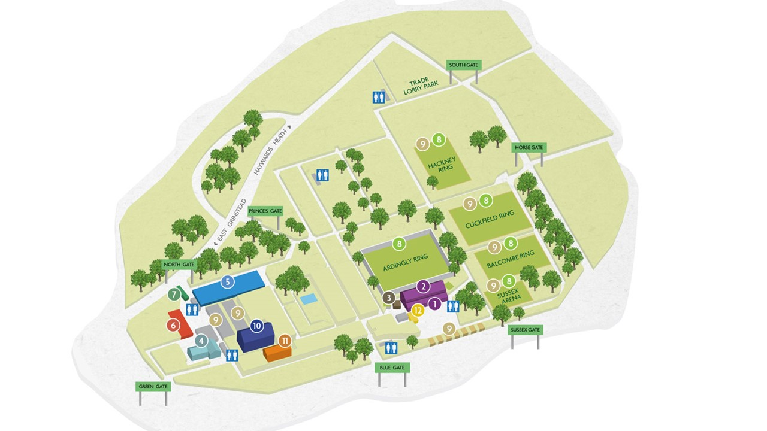

Upper Lindfield Suite = Building no 3

Norfolk Pavilion = Building no 2

